# *CS-255 System Design*

*Ryan Hatch  
October 13, 2023*

## Diagrams

### UML Use Case Diagram

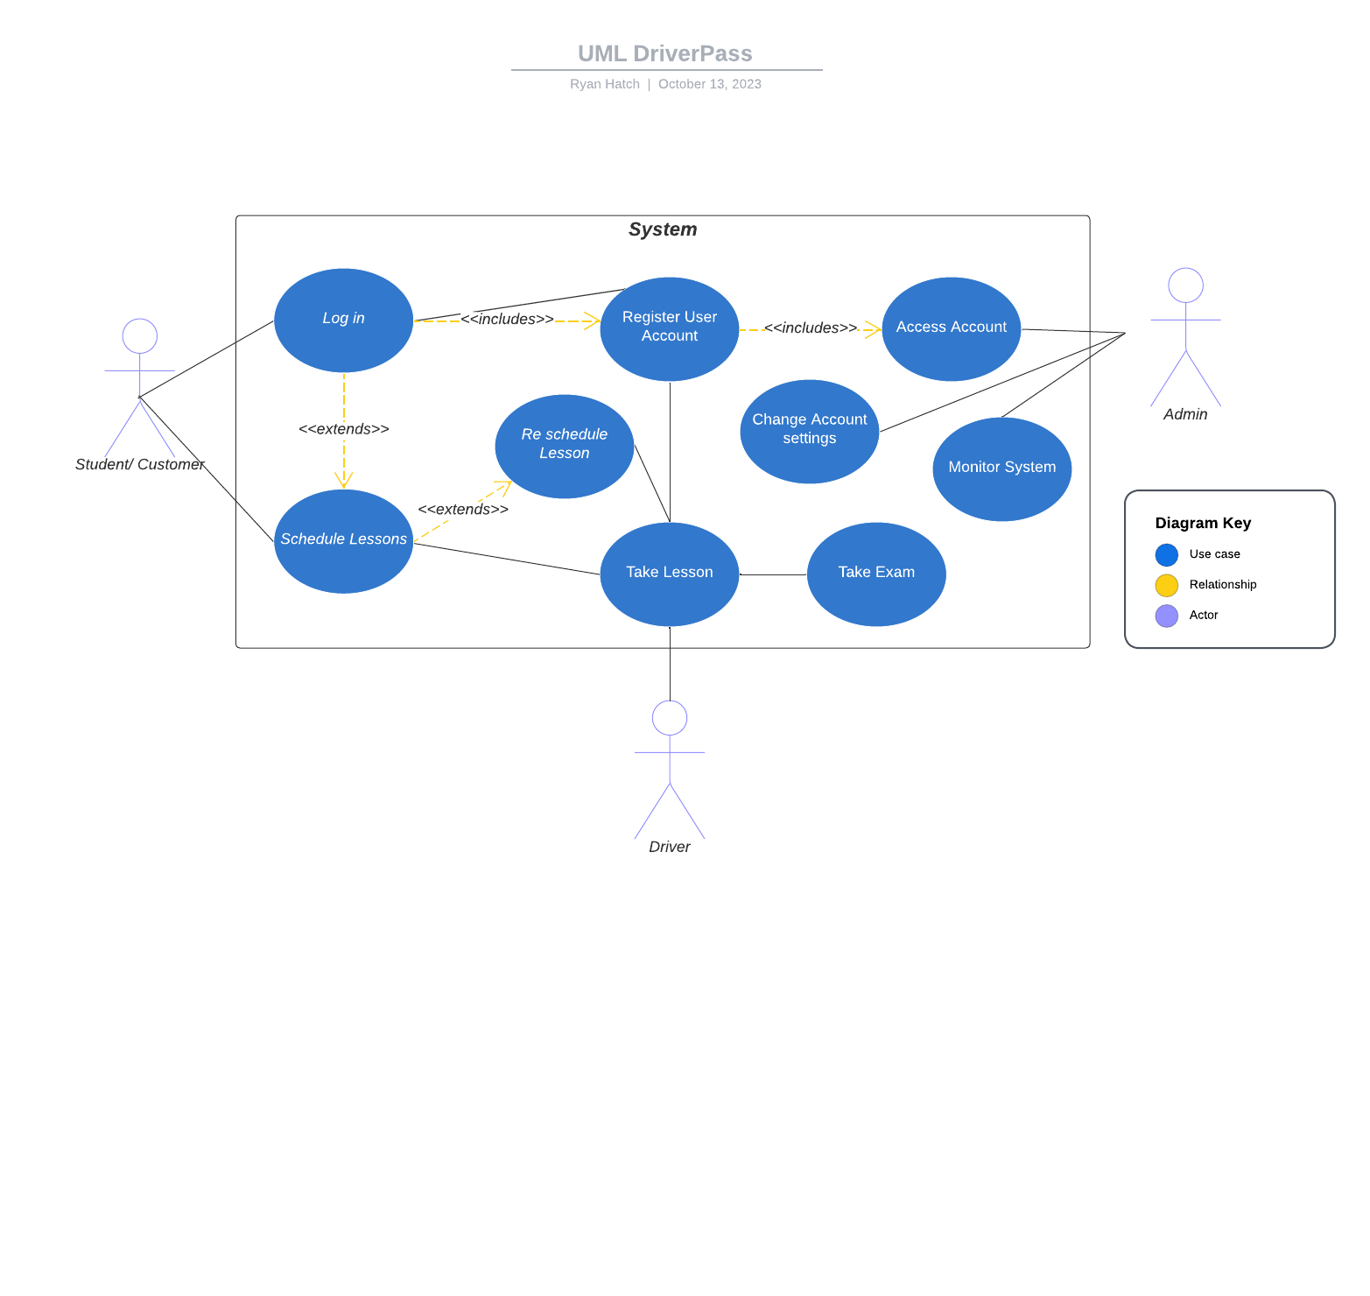

### UML Activity Diagrams

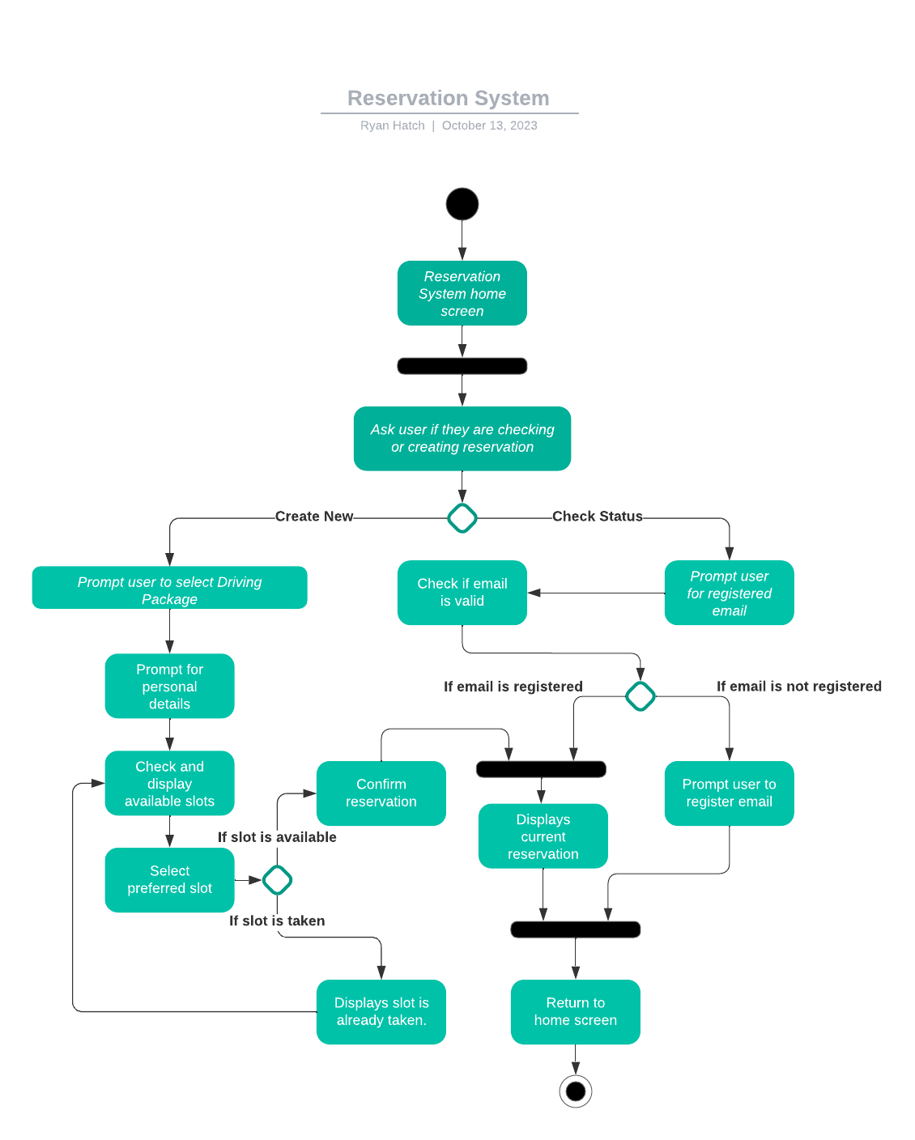

**UML Activity Diagrams**

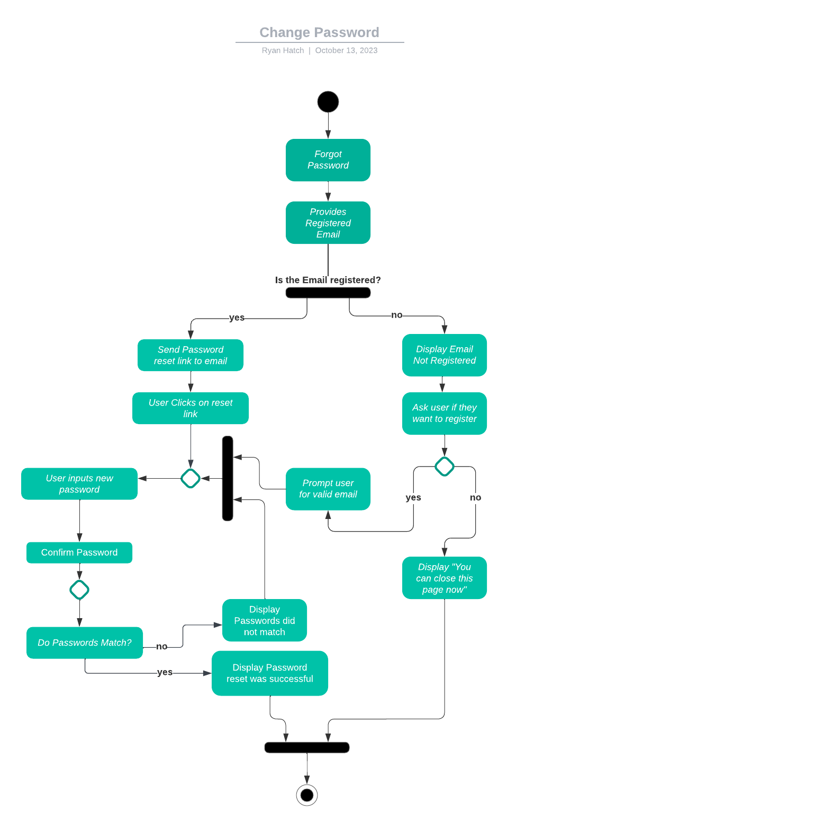

### UML Sequence Diagram

**

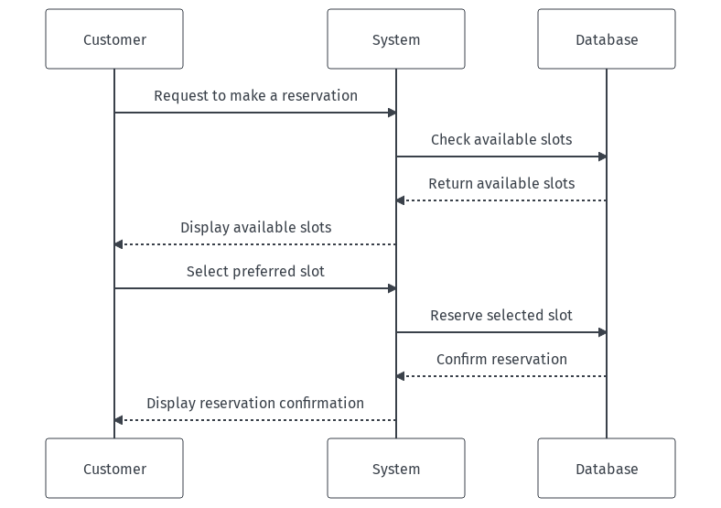

### UML Class Diagram

**

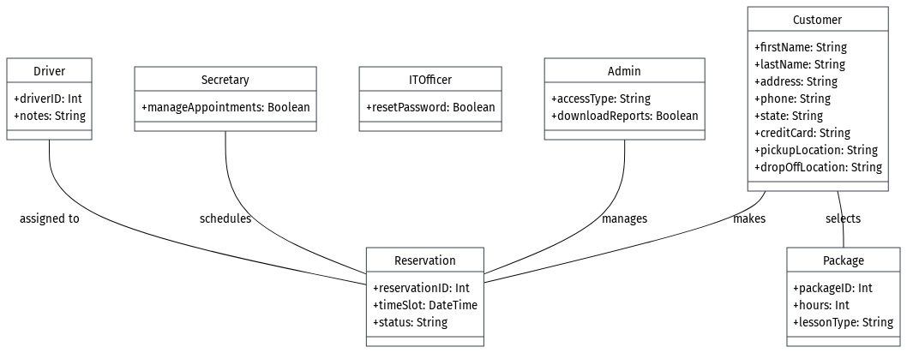

## Technical Requirements

* **Hardware Requirements:**
  + **Server Infrastructure:** A robust server infrastructure to host the web application and database. This should be scalable to handle potential growth in the number of users.
  + **Backup Servers:** To ensure data integrity and availability.
  + **Workstations:** For administrative staff and IT personnel to manage and maintain the system.
  + **Mobile Devices:** For drivers and other field staff to access the system while on the move.
* **Software Requirements:**
  + **Database Management System (DBMS):** A relational DBMS like MySQL or PostgreSQL to manage and store user data, reservations, packages, and other relevant information.
  + **Web Server:** Software like Apache or Nginx to host the web application.
  + **Web Application Framework:** A framework like Django (Python) or Spring Boot (Java) to develop the web application.
  + **Front-end Development Tools:** Technologies like HTML, CSS, JavaScript, and frameworks like React or Angular for a responsive and interactive user interface.
  + **Mobile Application (optional):** If there's a need for a dedicated mobile app for drivers or users, tools like Flutter or React Native can be used.
* **Tools:**
  + **Version Control:** Tools like Git and platforms like GitHub or Bitbucket for version control and collaborative development.
  + **Continuous Integration/Continuous Deployment (CI/CD):** Tools like Jenkins or Travis CI for automated testing and deployment.
  + **Project Management:** Tools like Jira or Trello for tracking development progress, managing tasks, and collaborating with the team.
* **Infrastructure:**
  + **Cloud Hosting:** Platforms like AWS, Google Cloud, or Azure to host the application and database. This ensures scalability, reliability, and ease of maintenance.
  + **Content Delivery Network (CDN):** To optimize content delivery speed for users across different locations.
  + **Secure Socket Layer (SSL) Certificate:** To ensure secure data transmission between the server and clients.
  + **Backup and Recovery Solutions:** Regular backups of the database and application to prevent data loss. This can be achieved using tools like AWS Backup or Google Cloud Backup.
* **Security:**
  + **User Authentication:** Implementing secure authentication mechanisms like OAuth or JWT to ensure only authorized users can access the system.
  + **Data Encryption:** Encrypting sensitive data, especially payment details and personal information, both at rest and in transit.
  + **Firewall and Intrusion Detection Systems (IDS):** To prevent unauthorized access and detect potential security threats.
  + **Regular Security Audits:** Periodic security assessments to identify and rectify vulnerabilities.
* **Integration:**
  + **DMV Integration:** A mechanism to connect with DMV systems for real-time updates on rules, policies, or sample questions. This might require APIs or webhooks.
  + **Payment Gateway Integration:** For processing payments when users register for driving packages.